Research Information

**Warriors**

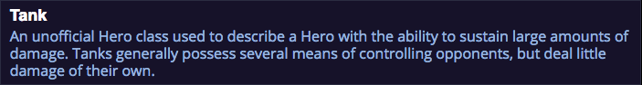

**Anub’arak**

**2. Overview**

Anub'arak is an aggressive anti-caster Warrior. His strongest points are his long-range disruption and high resistance to Ability-based damage. Although considered an archetypal [tank](http://www.icy-veins.com/heroes/glossary-of-terms#tank), his Health pool is significantly lower than that of other tanks; Anub'arak must therefore rely on his summons and Abilities to survive in battle.

**3. Strengths**

* Excellent [initiator](http://www.icy-veins.com/heroes/glossary-of-terms#initiate)
* Flexible Talent choices to adapt to opponents' strategy
* Several long-range [crowd control](http://www.icy-veins.com/heroes/glossary-of-terms#crowd-control) and [interruption](http://www.icy-veins.com/heroes/glossary-of-terms#interrupting) Abilities

**4. Weaknesses**

* Relatively fragile
* Limited damage dealing potential
* Main Abilities are [skillshots](http://www.icy-veins.com/heroes/glossary-of-terms#skillshot) that can be avoided

**5. Role in the Current Meta**

Anub'arak is a unique [tank](http://www.icy-veins.com/heroes/glossary-of-terms#tank) that sacrifices raw durability for [Spell Armor](http://www.icy-veins.com/heroes/glossary-of-terms#armor) and long-range [crowd-control-based](http://www.icy-veins.com/heroes/glossary-of-terms#crowd-control) utility than other tanks. As such, Anub'arak players are expected to aggressively provide crowd-control (through mpale Icon [Impale](http://heroesofthestorm.gamepedia.com/Anub'arak#Skills) and urrow Charge Icon [Burrow Charge](http://heroesofthestorm.gamepedia.com/Anub'arak#Skills)) for their teammates to [follow up](http://www.icy-veins.com/heroes/glossary-of-terms#follow-up) on with their own Abilities, and then pressure fragile [backline](http://www.icy-veins.com/heroes/glossary-of-terms#backline) Heroes. Finding the right time to [initiate](http://www.icy-veins.com/heroes/glossary-of-terms#initiate), [peel](http://www.icy-veins.com/heroes/glossary-of-terms#peeling), and pressure isolated Heroes while avoiding dangerous situations are the skills that one should develop in order to become a strong Anub'arak player.

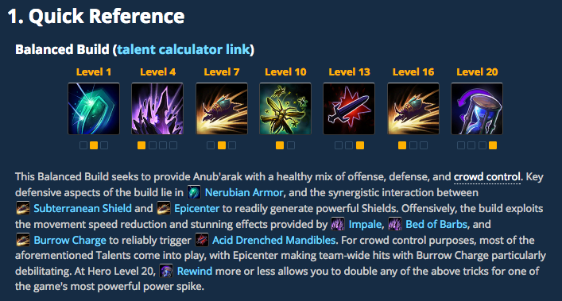

**Artanis**

**2. Overview**

Artanis is an aggressive [frontline](http://www.icy-veins.com/heroes/glossary-of-terms#frontline) Warrior that thrives on combat while below 75% maximum health, as hield Overload Icon [Shield Overload](http://heroesofthestorm.gamepedia.com/Artanis#Skills) and related talents can make him deceptively difficult to kill. Artanis' lack of innate [gap-closers](http://www.icy-veins.com/heroes/glossary-of-terms#gap-closer)means that he must commit to his lade Dash Icon [Blade Dash](http://heroesofthestorm.gamepedia.com/Artanis#Skills) + hase Prism Icon [Phase Prism](http://heroesofthestorm.gamepedia.com/Artanis#Skills) combination in order to effectively engage team fights from longer distances.

**3. Strengths**

* Great sustained damage
* hase Prism Icon [Phase Prism](http://heroesofthestorm.gamepedia.com/Artanis#Skills) can be used during lade Dash Icon [Blade Dash](http://heroesofthestorm.gamepedia.com/Artanis#Skills), which provides Artanis with unexpected mobility
* Once below 75% health, hield Overload Icon [Shield Overload](http://heroesofthestorm.gamepedia.com/Artanis#Skills) can make Artanis very difficult to kill if not focused
* Both uppression Pulse Icon [Suppression Pulse](http://heroesofthestorm.gamepedia.com/Artanis#Talents) and urifier Beam Icon [Purifier Beam](http://heroesofthestorm.gamepedia.com/Artanis#Talents) are global, allowing Artanis to influence team fighs from anywhere on the battlefield
* Uses very little Mana

**4. Weaknesses**

* Can get [kited](http://www.icy-veins.com/heroes/glossary-of-terms#kite) easily
* hield Overload Icon [Shield Overload](http://heroesofthestorm.gamepedia.com/Artanis#Skills) only activates once below 75% health
* [Crowd control](http://www.icy-veins.com/heroes/glossary-of-terms#crowd-control) can prevent Artanis from using his Basic Attacks, making him unable to recoup hield Overload Icon [Shield Overload](http://heroesofthestorm.gamepedia.com/Artanis#Skills)

**5. Role in the Current Meta**

Artanis cane be played as a stalwart [Tank](http://www.icy-veins.com/heroes/glossary-of-terms#tank) or an aggressive [Bruiser](http://www.icy-veins.com/heroes/glossary-of-terms#bruiser). In both roles, he thrives on extended combat, as long he is able to consistently attack a nearby target. Aside from hase Prism Icon [Phase Prism](http://heroesofthestorm.gamepedia.com/Artanis#Skills), lade Dash Icon [Blade Dash](http://heroesofthestorm.gamepedia.com/Artanis#Skills) is Artanis' only[gap-closer](http://www.icy-veins.com/heroes/glossary-of-terms#gap-closer). In order for Artanis to reach enemy ranged Heroes, assistance from his team is usually required. Additionally, [crowd control](http://www.icy-veins.com/heroes/glossary-of-terms#crowd-control) counters Artanis hard, as he must be able to use Basic Attacks to keep up his shields from hield Overload Icon [Shield Overload](http://heroesofthestorm.gamepedia.com/Artanis#Skills).

Due to his lack of [crowd control](http://www.icy-veins.com/heroes/glossary-of-terms#crowd-control) and gap-closers, Artanis relies more heavily on his team than other Heroes. For instance, Jaina and Muradin are able to Slow and Stun enemies, making much easier for Artanis to stick to a target. [Tassadar](http://www.icy-veins.com/heroes/tassadar-build-guide) is another Hero that synergises well with Artanis. lasma Shield Icon [Plasma Shield](http://heroesofthestorm.gamepedia.com/Tassadar#Skills) provides survivability without healing Artanis past 50% of his maximum health, allowing him to still benefit from Shield Overload. Conversely, be wary of picking Artanis into teams with plenty of Stuns and burst damage.

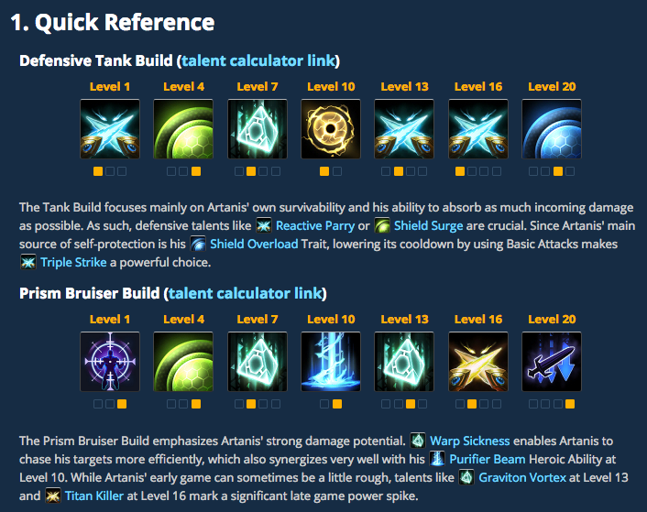

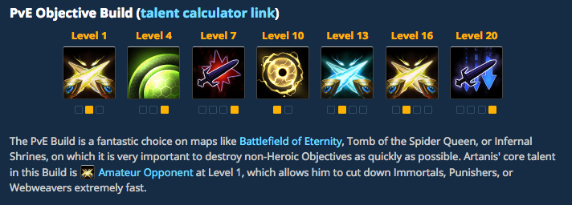

**Arthas**

**2. Overview**

Arthas is an aggressive Warrior who can be played both as a [Bruiser](http://www.icy-veins.com/heroes/glossary-of-terms#bruiser) and as a [Tank](http://www.icy-veins.com/heroes/glossary-of-terms#tank). Arthas excels at slowing and rooting several opponents at the same time, which allows him to either chase down retreating enemies or to [peel](http://www.icy-veins.com/heroes/glossary-of-terms#peeling)for threatened allies. Furthermore, his inherent 15 Physical Armor (which causes him to take 15% reduced damage from enemy Basic Attacks) and the ability to reduce the Attack Speed of nearby opponents, make him an excellent choice against Assassins who are dependent on Basic Attacks.

**3. Strengths**

* Powerful crowd control abilities
* Good at clearing Mercenary Camps on his own
* Strong self-sustain
* Resilient against Basic Attacks
* High damage output compared to other Warriors
* Decent laner

**4. Weaknesses**

* No [gap-closers](http://www.icy-veins.com/heroes/glossary-of-terms#gap-closer)
* Mana dependent
* Relatively long cooldown on both Heroic Abilities

**5. Role In The Current Meta**

Arthas fulfills the role of an offensive Warrior that poses a constant threat to nearby enemies. While he is innately not as durable as other Warriors like [Muradin](http://www.icy-veins.com/heroes/muradin-build-guide) or [E.T.C.](http://www.icy-veins.com/heroes/e-t-c-build-guide), Arthas can nevertheless become quite tanky. Strong defensive talents like mmortal Coil Icon [Immortal Coil](http://heroesofthestorm.gamepedia.com/Arthas#Talents) or nti-Magic Shell Icon [Anti-Magic Shell](http://heroesofthestorm.gamepedia.com/Arthas#Talents) provide enough protection to hold the front line during the later stages of the game against both Basic Attackers and Spell Casters. Two of Arthas' Basic Abilities, namely rozen Tempest Icon [Frozen Tempest](http://heroesofthestorm.gamepedia.com/Arthas#Skills) and owling Blast Icon [Howling Blast](http://heroesofthestorm.gamepedia.com/Arthas#Skills), can be used to [initiate](http://www.icy-veins.com/heroes/glossary-of-terms#initiate) team fights by locking multiple nearby enemies down. However, the fact that Arthas has a hard time closing in on agile Heroes requires him to choose his targets wisely. In order to become a decent Arthas player, it is very important to know when to engage and when to remain passive.

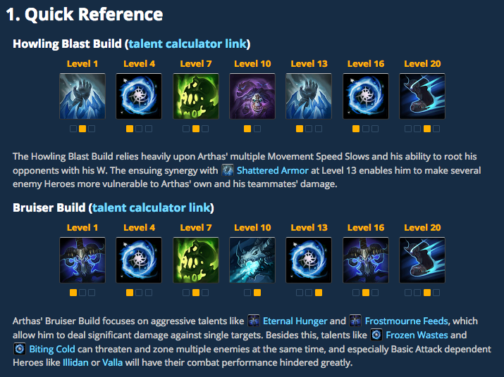

**Chen**